**Board Of Director – Nomination Form**

The EIC Board of Director nominees must meet the following criteria as outlined in the EIC Bylaws:

* Must be a resident of San Jose (incorporated or unincorporated areas).
* Must be at least 25 years’ old.
* A voting member of the organization who has maintained membership for a period of 2 consecutive years, immediately preceding the election year.
* A US citizen **OR** US Permanent Resident **OR** Person on a Work Visa (for example H1-B, L1) with an approved I-140 petition by USCIS **AND** 5 years of residence in San Jose.
* Agrees to maintain voting membership status during the BoD tenure.
* 1 Year of active volunteer experience in any committee at Evergreen Islamic Center certified by committee lead.

The deadline to submit nomination is **Sunday October 8th, 2023; 9 PM PT.** Forms must be typed. Handwritten forms **will not** be accepted.

Please submit the completed nomination forms to any of the EIC Election Committee Members, in person or via email, on or before the deadline.

**Election timeline for reference:**

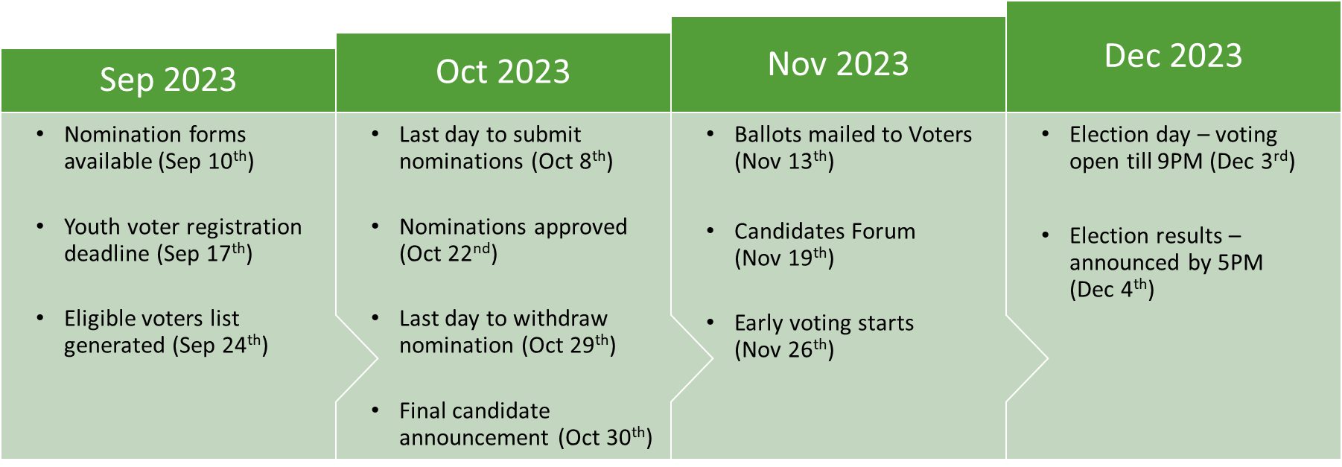

**Election Committee:**

For any questions or clarifications, please contact the following individuals:

|  |  |  |
| --- | --- | --- |
| Name | Contact | E-mail Address |
| Br. Atiq Ahmed | (650) 963-6079 | Election-admin@eicsanjose.org |
| Br. Ghazzali Majeed | (408) 887-6051 |
| Br. Zaki Hassan | (408) 204-2095 |

**Board Of Director – Nomination Form 2023**

|  |  |  |
| --- | --- | --- |
| **Nominee’s Name** | **Phone #** | **Address** |
|  |  |  |
| **Nominated by (Name)** | **Phone #** | **Address** |
|  |  |  |
| **Seconded by (Name)** | **Phone #** | **Address** |
|  |  |  |
| **Committee Lead (Name)** | **Phone #** | **Activities supported** |
|  |  |  |

**Nominee’s acceptance:** I, **________________________________,** accept the nomination. I declare that all the details provided in this form are accurate. I believe in the Oneness of Allah (SWT) and the finality of Prophet Muhammad (PBUH). If elected, I will fulfill my responsibilities in accordance with EIC’s bylaws.

Signature: ___________________________________ Date: ________________

**Important:** *All entries of the form should be filled. This form will be shared with the general membership of EIC prior to election. Incomplete or Incorrect nomination forms will be rejected.*

**Describe how personal and professional experience/qualification will help the nominee in the BoD role**

**Nominee’s Manifesto (A Brief plan how Nominee will contribute to EIC as BoD)**

**Nominee’s time/effort spent volunteering at EIC.**