**Youth Voter Registration Form 2023**

Students between the ages of 18-25 and whose parents meet the EIC Voter eligibility requirements should submit the form to receive the Ballot.

The deadline to submit nomination is **Sunday September 17th, 2023; 9 PM PT.**

Please submit the completed forms to any of the EIC Election Committee Members, in person or via email, on or before the deadline.

**Election timeline for reference:**

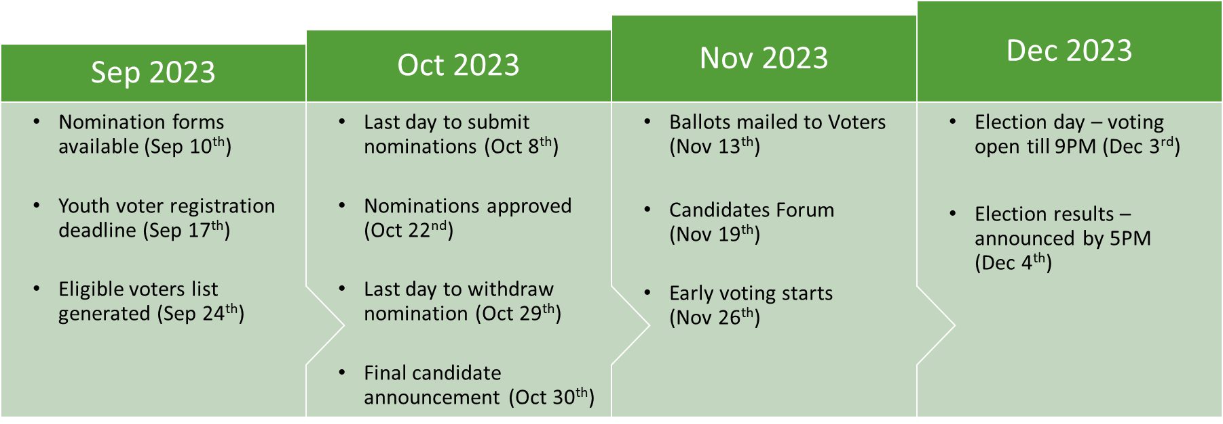

**Election Committee:**

For any questions or clarifications, please contact the following individuals:

|  |  |  |
| --- | --- | --- |
| Name | Contact | E-mail Address |
| Br. Atiq Ahmed | (650) 963-6079 | Election-admin@eicsanjose.org |
| Br. Ghazzali Majeed | (408) 887-6051 |
| Br. Zaki Hassan | (408) 204-2095 |

**Youth Voter Registration Form 2023**

|  |  |
| --- | --- |
| **Name** |  |
| **Date of Birth** |  |
| **Father’s Name** |  |
| **Mother’s Name** |  |
| **Current Home Address** |  |

**Youth acceptance:** I, **________________________________,** declare that all the information provided in this form is accurate.

Signature: ________________________________ Date: ________________